

**END OF TERM ONE EXAMINATIONS 2023**

**BABY CLASS**

**LANGUAGE DEVELOPMENT TWO**

NAME_______________________________

1. **Colour sound “s**”.

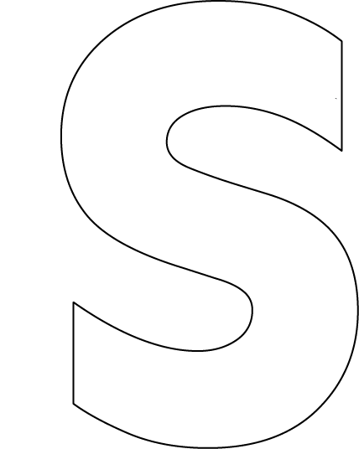

1. **Colour friends of the sound**.

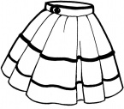

1. 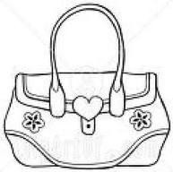Trace and colour.
2. Copy and write

t

p

1. Match the same.

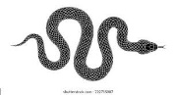







1. Colour sound “a”.

